Zeeman Effect Lab

*By: Alex Liechty, Crystal Nelson, Junhua Deng*

*Date: May 24, 2022-June 5, 2022*

## Theory Exercises (AL, CN, JD 5/26/2022-)

1. The instrument finesse is given by (peak separation) / (peak width), which can be estimated using the data we collected from the green Mercury lines with no magnetic field. Looking at the data for the green lines, the peak separation is around 1200 - 450 = 750 indices. An estimate for the peak width is around 50 indices. This means an estimate for our instrument finesse is (750 / 50) = 15.
2. The Mercury lines observed in this experiment are given below:

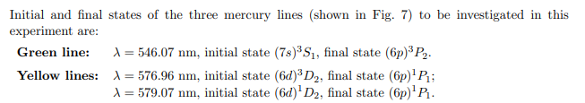

Energy level diagrams for these transitions are:

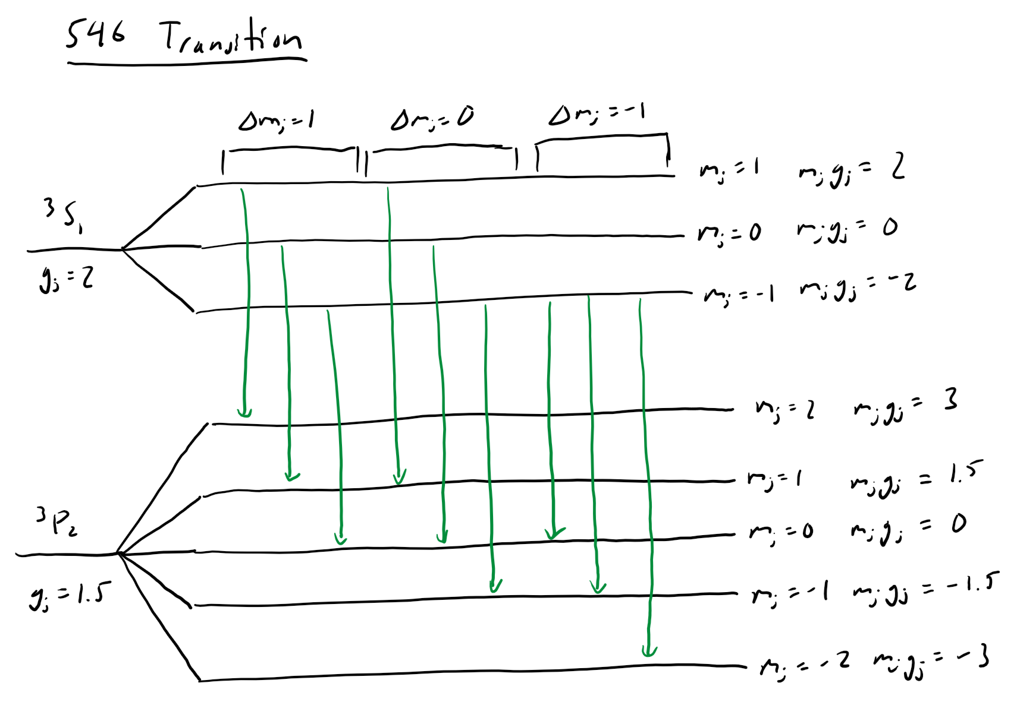

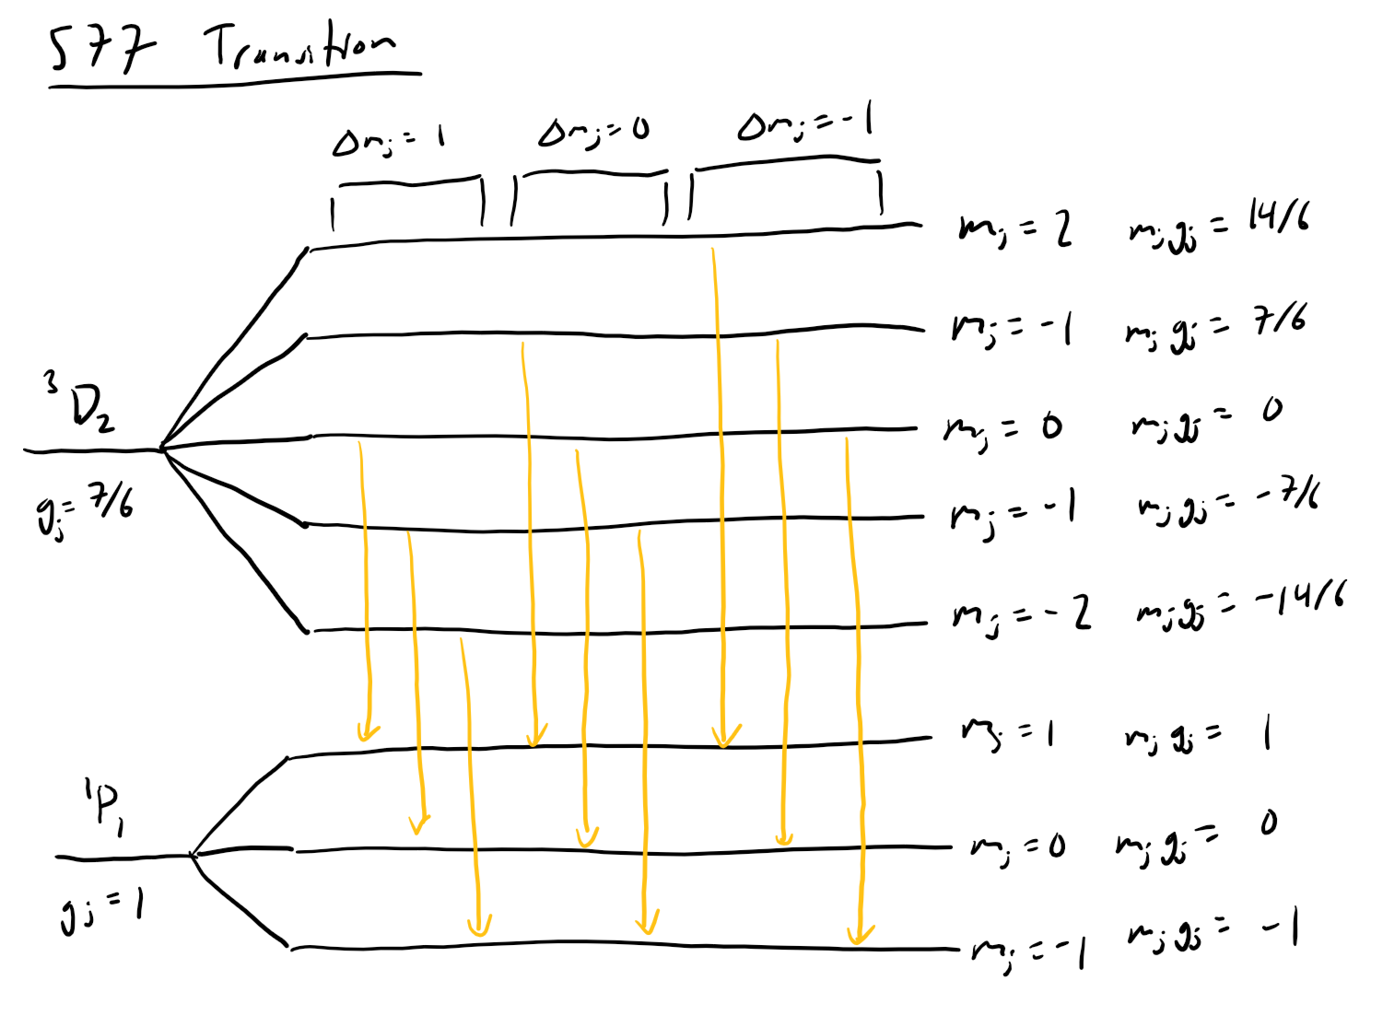

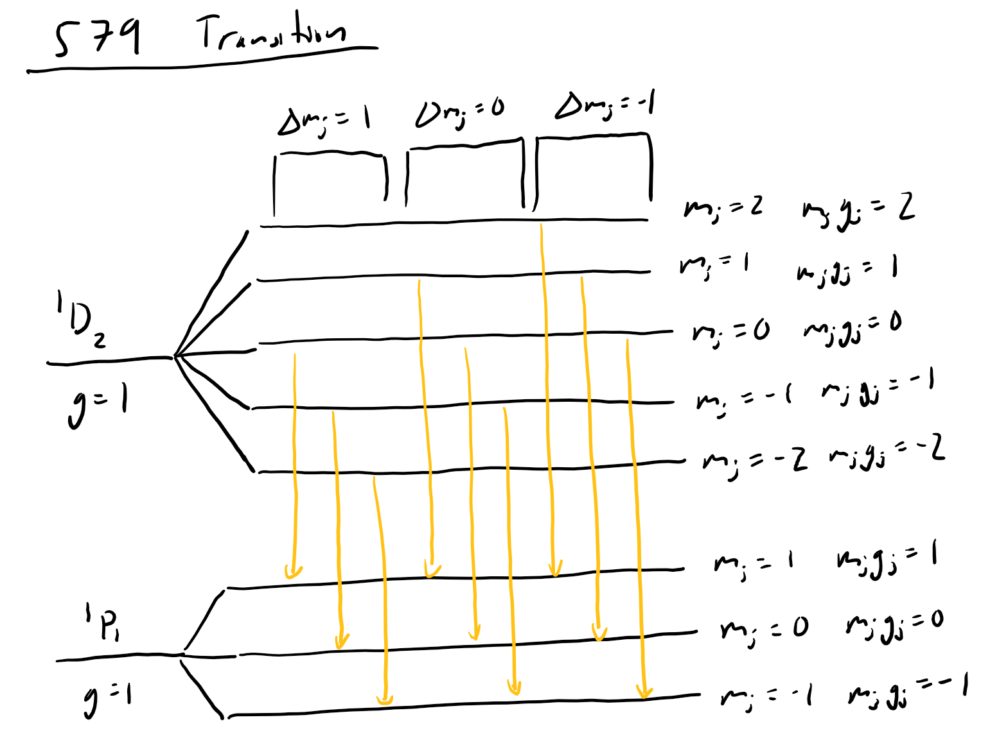

1. Using the formula given in the experiment instructions (shown below), and using the gj and mjvalues from the diagrams above:

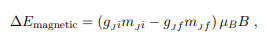

For the 546 nm lines, the predicted values are:

|  |  |  |  |
| --- | --- | --- | --- |
| **Δmj** | **(gjmj)i** | **(gjmj)f** | **ΔE (in μBB)** |
| 1 | 2 | 3 | -1 |
| 1 | 0 | 3/2 | -3/2 |
| 1 | -2 | 0 | -2 |
| 0 | 2 | 3/2 | 1/2 |
| 0 | 0 | 0 | 0 |
| 0 | -2 | -3/2 | -1/2 |
| -1 | 2 | 0 | 2 |
| -1 | 0 | -3/2 | 3/2 |
| -1 | -2 | -3 | 1 |

A diagram of these lines:

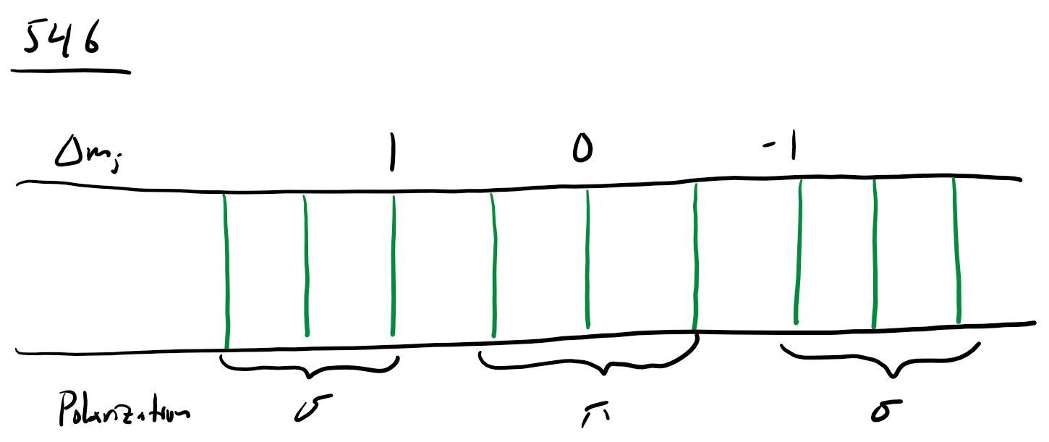

For the 577 nm lines, the predicted values are:

|  |  |  |  |
| --- | --- | --- | --- |
| **Δmj** | **(gjmj)i** | **(gjmj)f** | **ΔE (in μBB)** |
| 1 | 0 | 1 | -1 |
| 1 | -7/6 | 0 | -7/6 |
| 1 | -14/6 | -1 | -4/3 |
| 0 | 7/6 | 1 | 1/6 |
| 0 | 0 | 0 | 0 |
| 0 | -7/6 | -1 | -1/6 |
| -1 | 14/6 | 1 | 4/3 |
| -1 | 7/6 | 0 | 7/6 |
| -1 | 0 | -1 | 1 |

A diagram for these lines:

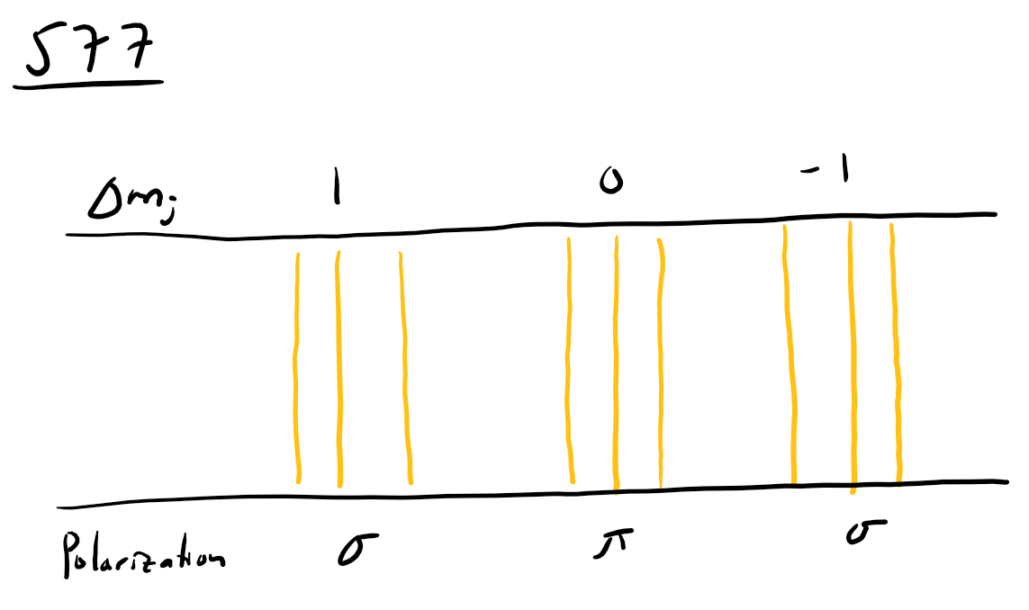

For the 579 nm lines, the predicted values are:

|  |  |  |  |
| --- | --- | --- | --- |
| **Δmj** | **(gjmj)i** | **(gjmj)f** | **ΔE (in μBB)** |
| 1 | 0 | 1 | -1 |
| 1 | -1 | 0 | -1 |
| 1 | -2 | -1 | -1 |
| 0 | 1 | 1 | 0 |
| 0 | 0 | 0 | 0 |
| 0 | -1 | -1 | 0 |
| -1 | 2 | 1 | 1 |
| -1 | 1 | 0 | 1 |
| -1 | 0 | -1 | 1 |

A diagram for these lines:

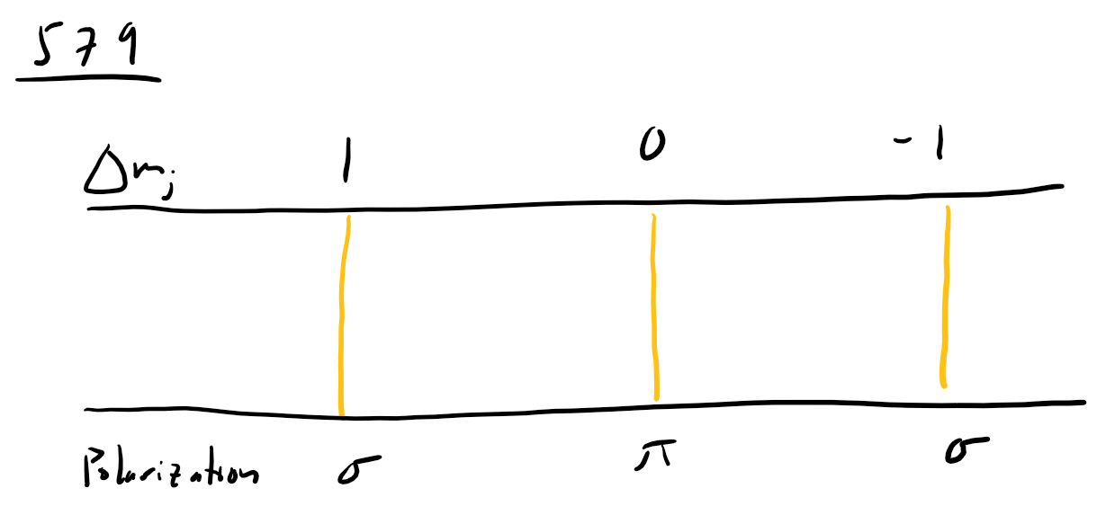

## Background & Setup (AL, CN, JD 5/24/2022-5/26/2022)

Experiment background.

The Zeeman effect is a name for when a magnetic field interacts with the total angular momentum and splits a spectral line. The spectral lines still may show up at the original wavelength, but there should also be lines above and below it from where the magnetic field split the line. This is because the degeneracy in angular momentum can cause a displacement. The magnetic moments of the electrons (related to their total angular momenta) cause them to move into different states, one at the original energy level, one higher, and one lower. The displacement created is related to the magnetic field strength, and thus can be used with other information to calculate an unknown magnetic field and vice versa.

Here is an annotated diagram of our setup:



Here is also a photo of our setup for clarity: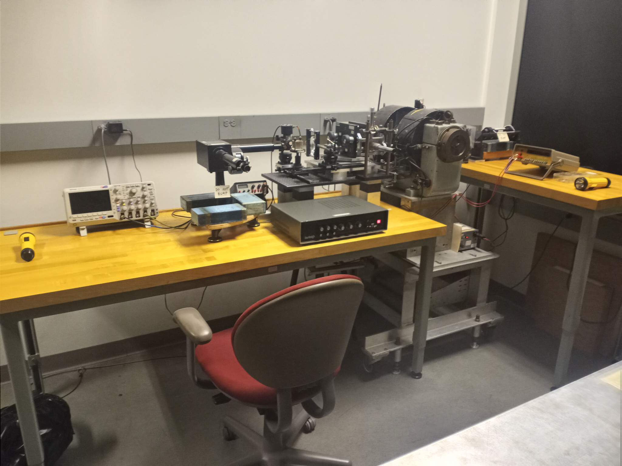

## Experiment Notes (AL, CN, JD 5/24/2022-)

Equipment settings for our experiment:

* Green Lens B Current: 3.580 A ± 0.0005A
* Yellow Lens B Current: 1.591 A ± 0.0005A
* Mirror Separation:

|  |  |  |
| --- | --- | --- |
| Right Edge | Left Edge | Separation |
| 21.22 mm ± 0.005mm | 22.98 mm ± 0.005mm | 1.76 mm ± 0.01mm |
| 21.06 mm ± 0.005mm | 22.96 mm ± 0.005mm | 1.90 mm ± 0.01mm |
| 21.20 mm ± 0.005mm | 22.96 mm ± 0.005mm | 1.76 mm ± 0.01mm |
| 21.50 mm ± 0.005mm | 22.95 mm ± 0.005mm | 1.45 mm ± 0.01mm |

These values give a free spectral range of 87.3 +/- 8.4 GHz.

Our first day of data collection, we only did practice runs. Thus our official data started on the 26th due to issues we had with the range on the PDA-700 current amplifier. These were resolved on the next day, and we were able to take the data sets. Our specific settings for our data are listed above. The scope screens of the data we collected can be seen below, the datasets we collected were from these screens.

Green lines with no magnetic field:

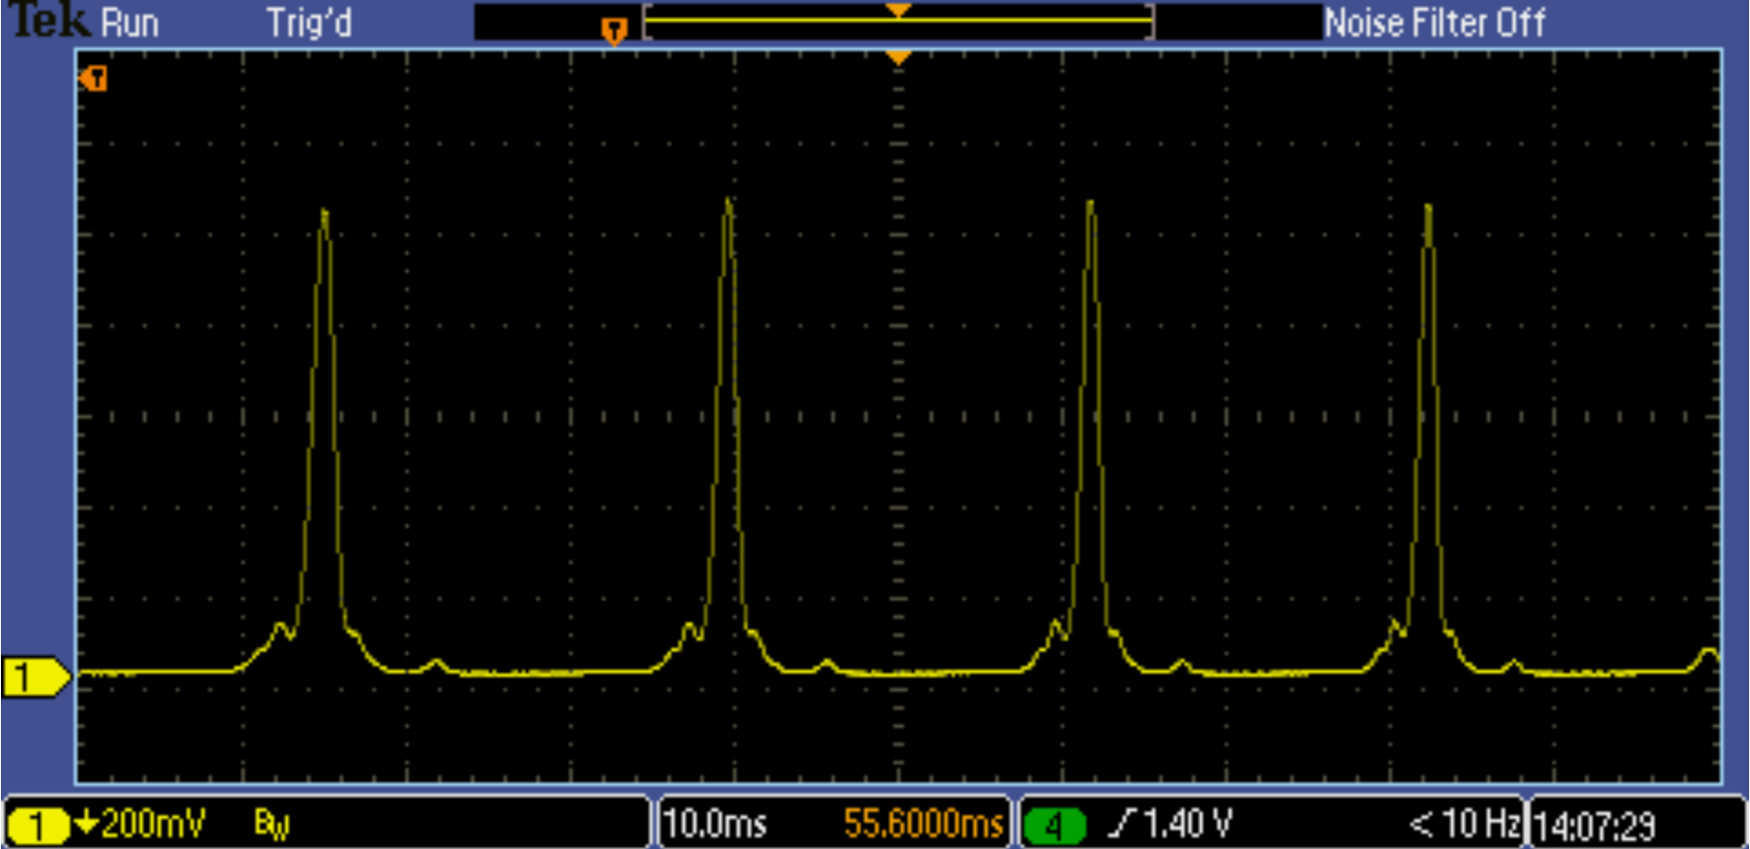

Green lines with 3.580A of applied current to the magnet:

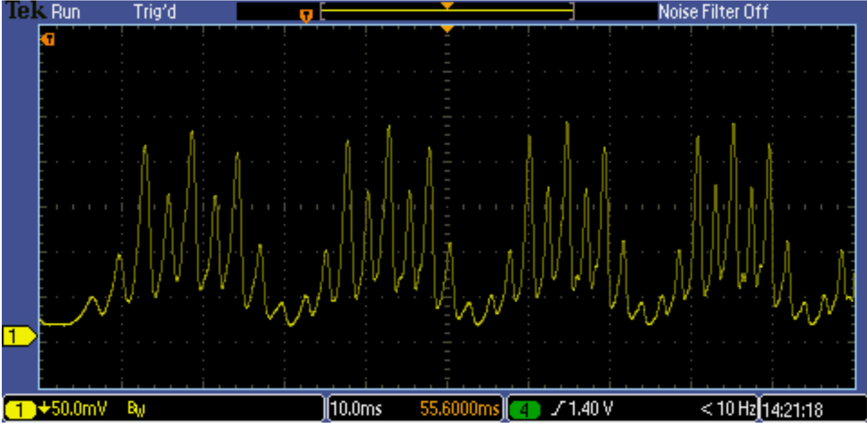

Green lines with 3.580A of applied current with π polarization:

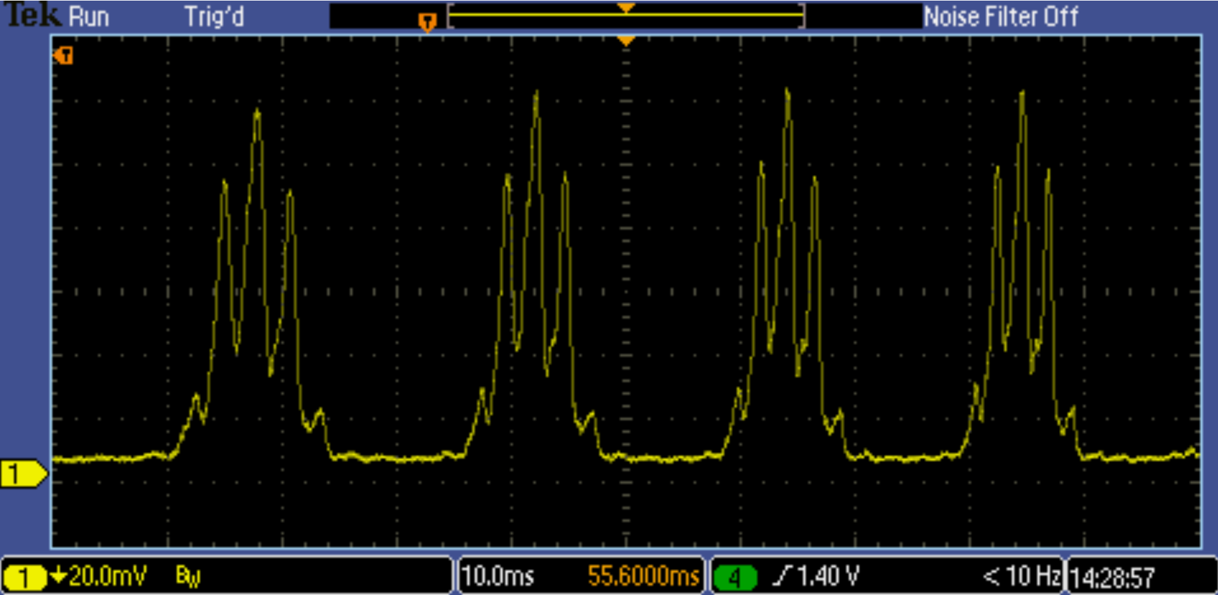

Green lines with 3.580A of applied current with σ polarization:

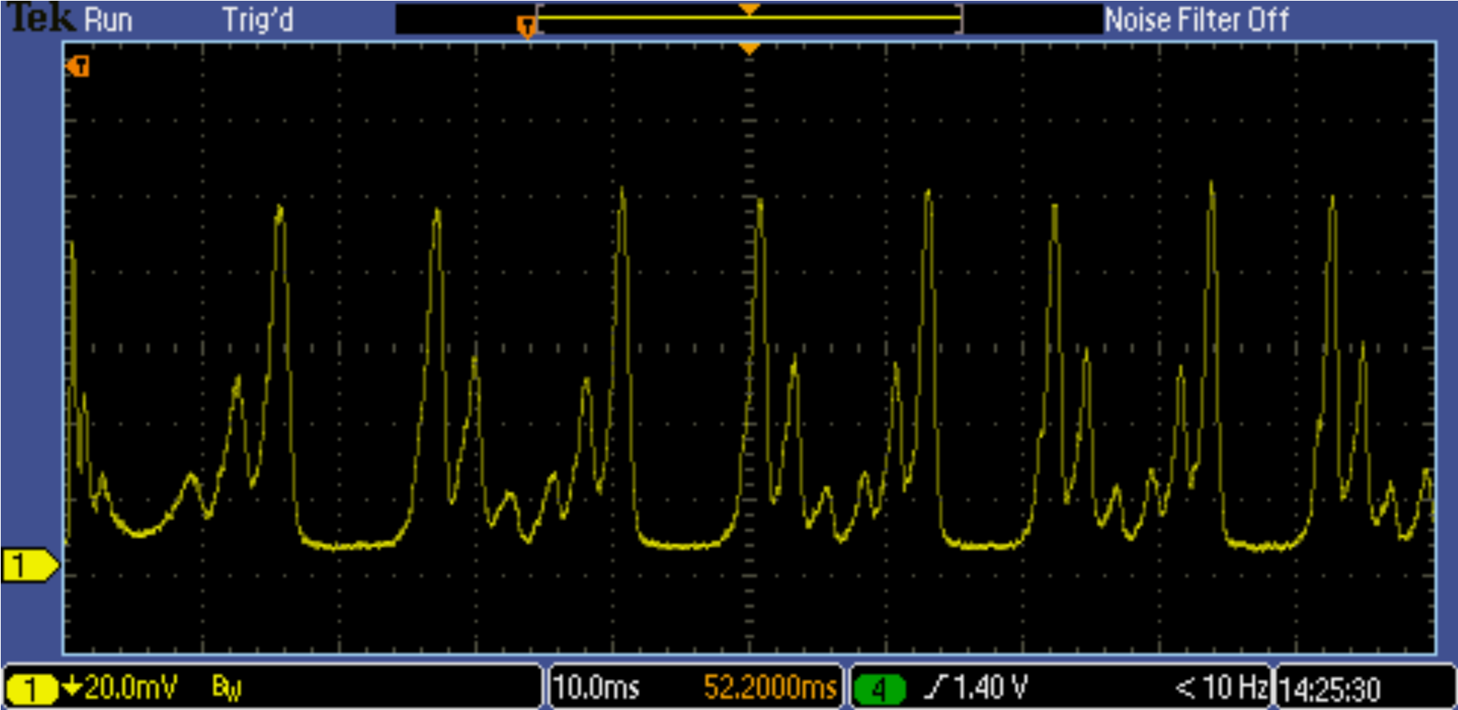

Yellow lines with no magnetic field:

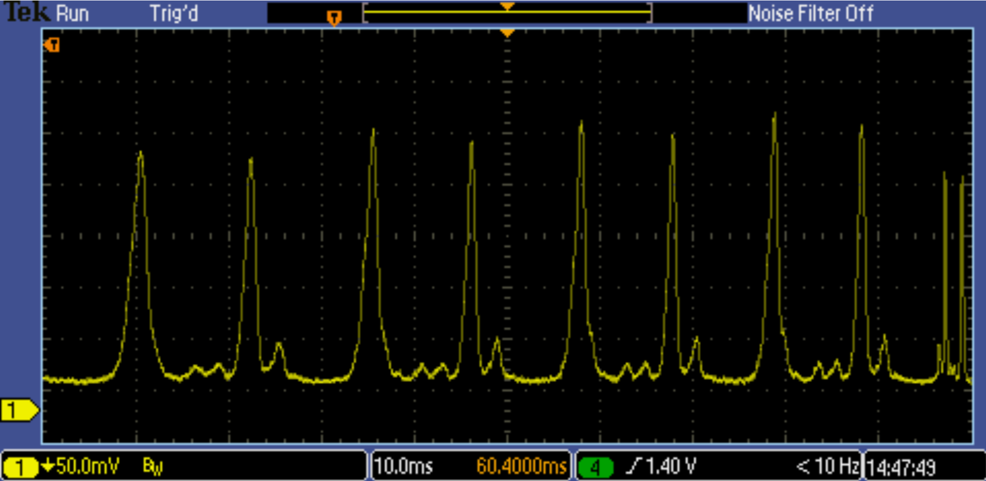

Yellow lines with 1.591 A of applied current to magnet

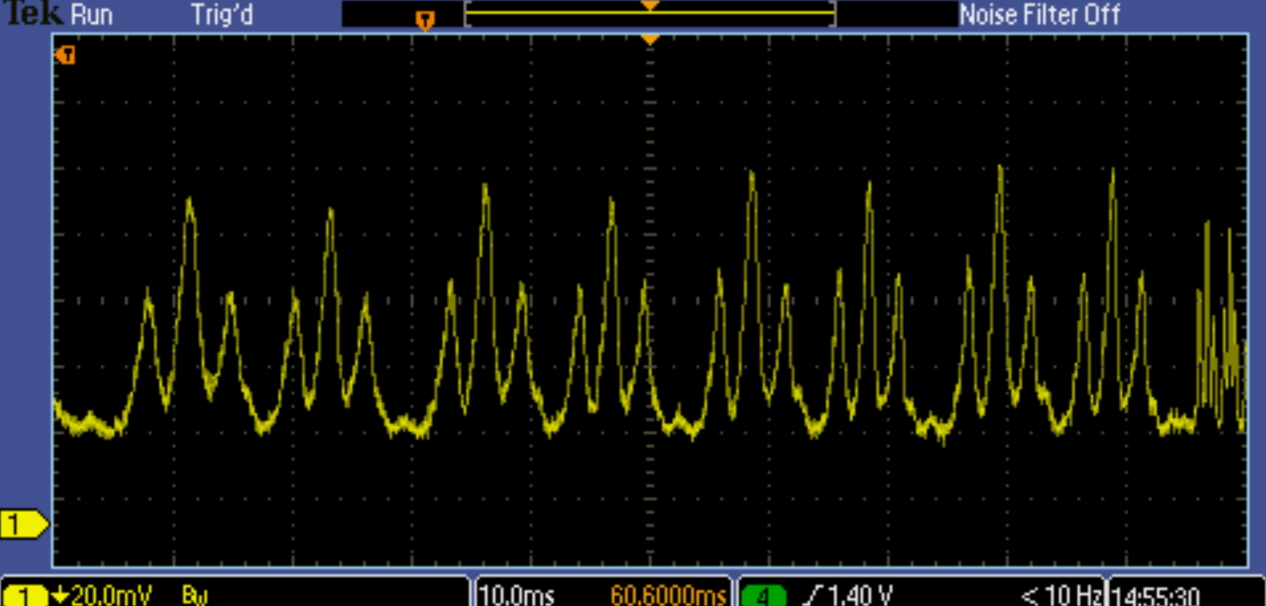

Yellow lines with 1.591A of applied current with π polarization:

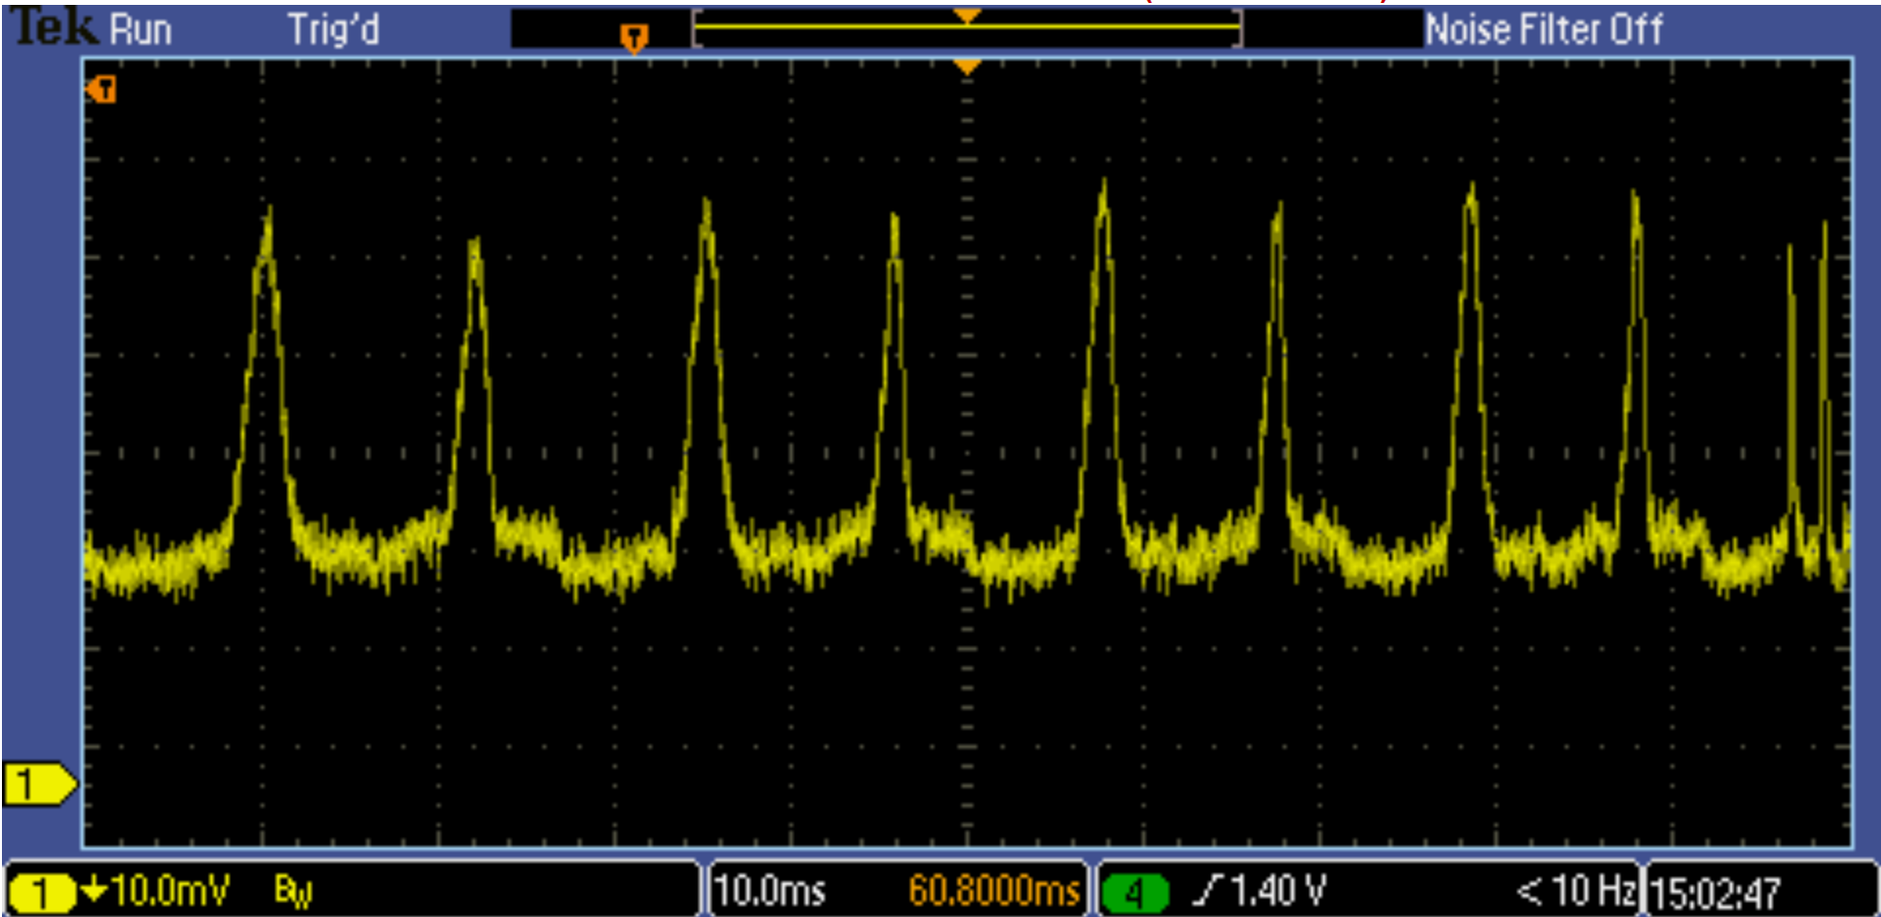

Yellow lines with 1.591A of applied current with σ polarization:

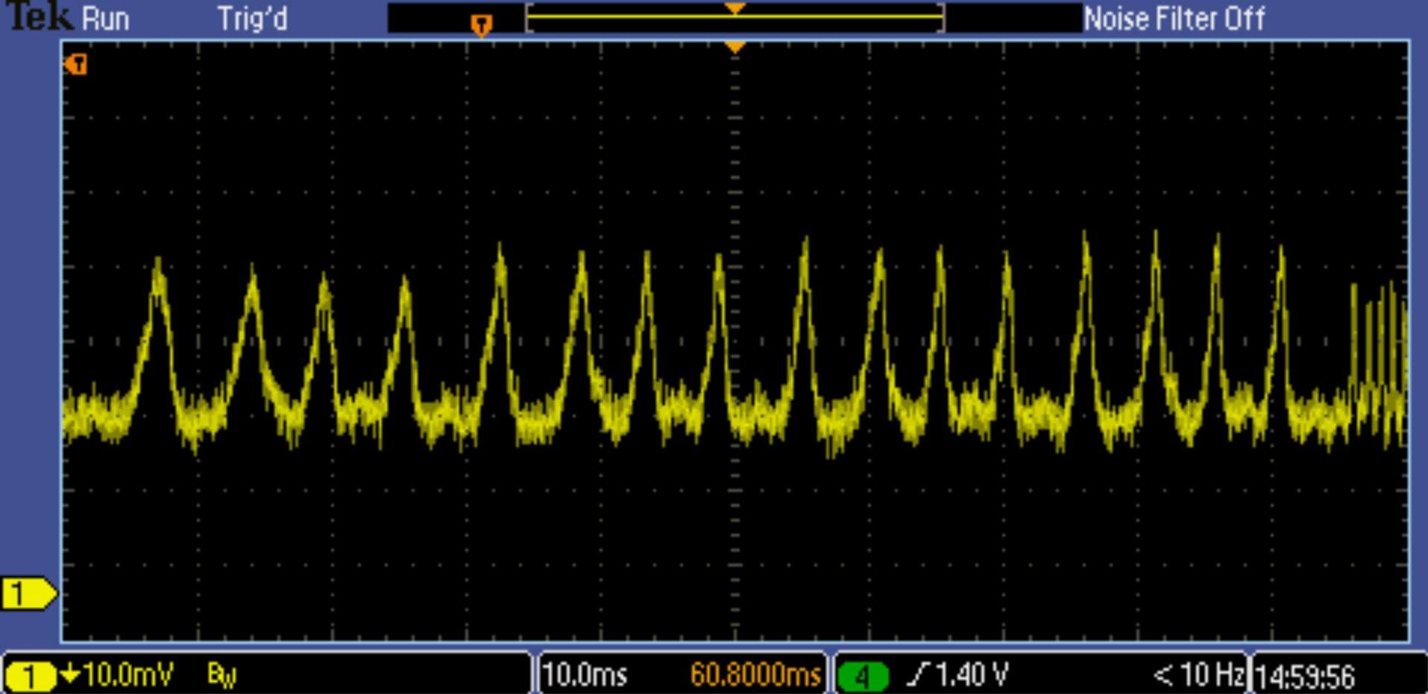

## Data Reduction & Preliminary Results (AL, CN, JD 5/26/2022-)

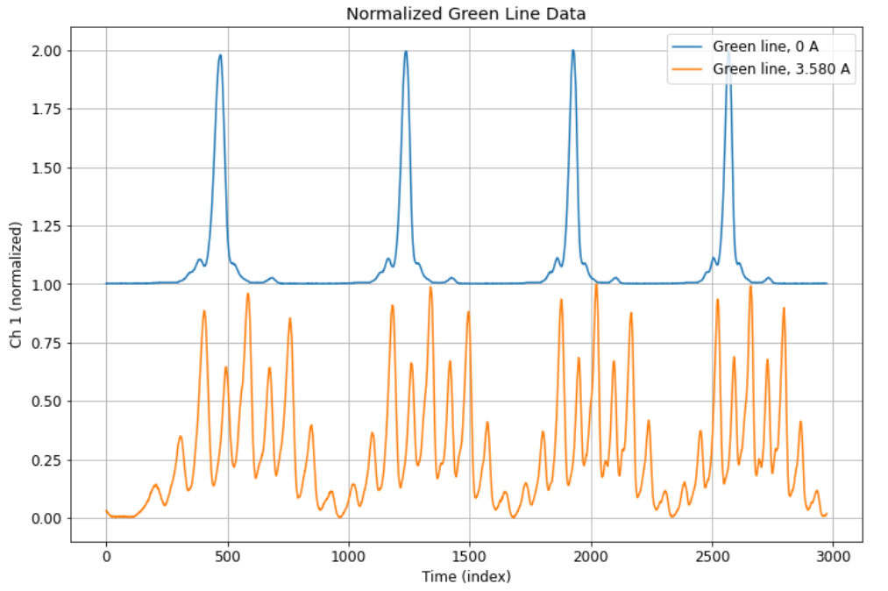

These results are as expected. The Zeeman splitting of the green line resulted in 9 peaks which is expected (see theory exercises). In order to analyze these peaks, the data will be put through a peak finding algorithm and the horizontal scale will be changed to be in units of the free spectral range (FSR) which can be found using the green peaks with no magnetic field. This allows for the energy shift between spectral lines due to the magnetic field to be measured and compared to theory.

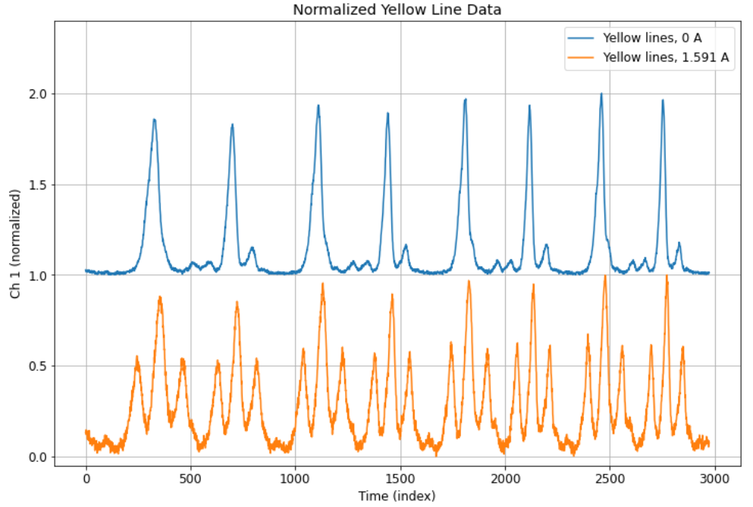

These results are also what we expected for the yellow lines. Since there are two yellow lines at 577nm and 579nm, these peaks are close together and are both shown on the data. It was expected for both of these lines that there should be 3 Zeeman split levels (at low enough magnetic field). In order to analyze this data, the data first needed to be separated into the 577 and 579 lines. After this, the peaks would be found using the same peak-finding algorithm and scaled into units of the FSR. Finally, the peak differences can be found for both the 577 and 579nm lines which give measured energy shifts due to the magnetic field which can be compared to the values found in theory.

## 

## Final Analysis (AL, CN, JD 5/31/2022-)

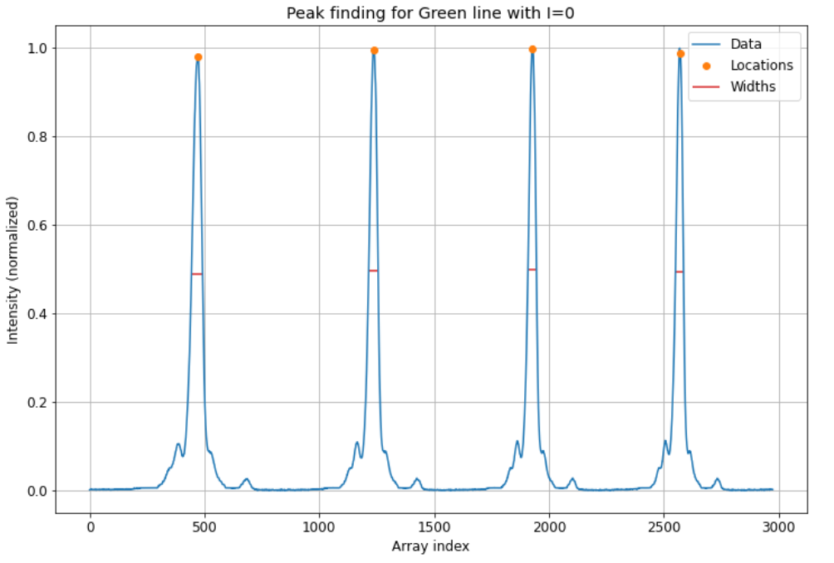

This is the peak-finding for the green line with no magnetic current. This data was used to find the instrument finess which is defined as (peak separation) / (peak width). From our data we found the instrument finess to be 17.2 +/- 2.2. This is close to our eyeball estimate from experiment 1.

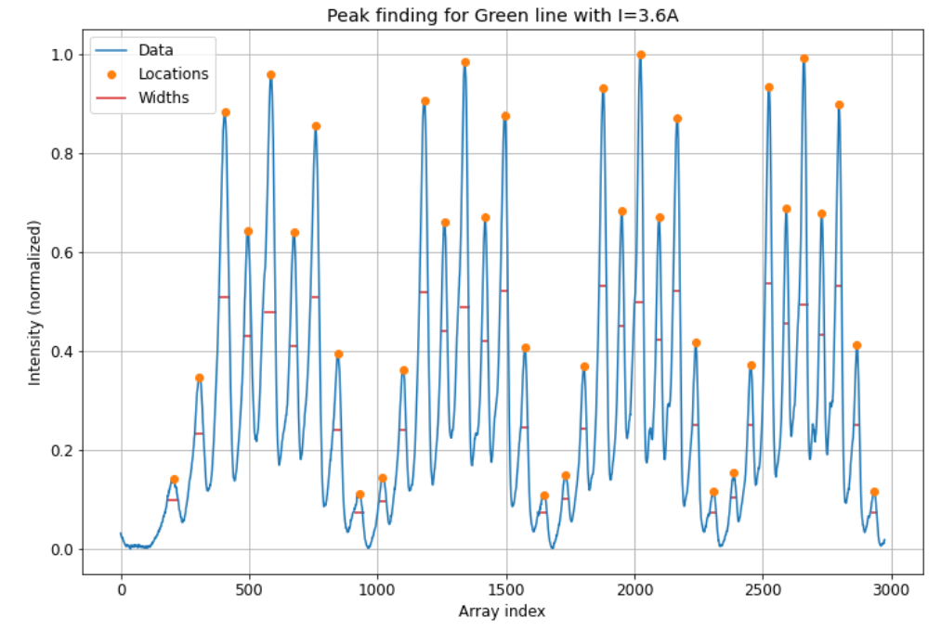

This is the peak finding plot for the green lines with an applied magnetic field, the comparison of the measured energy shifts from these peaks and predicted values can be seen below:

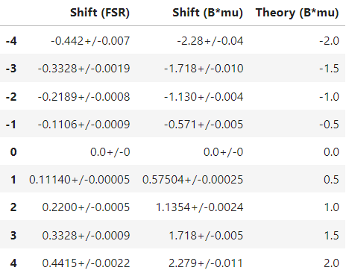

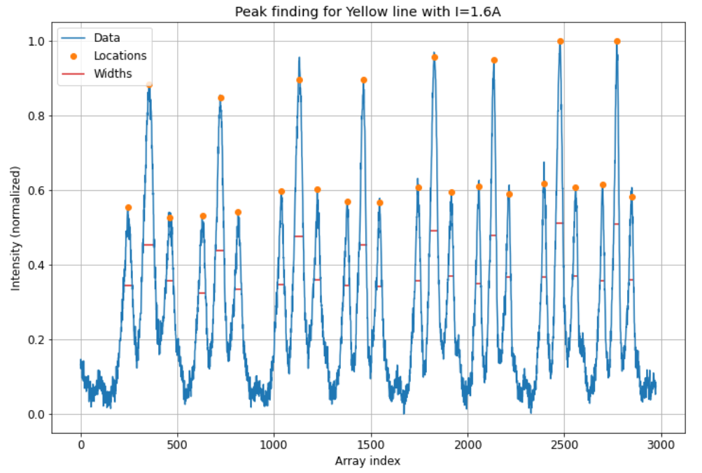

This is the peak finding plot for the yellow lines. This plot includes both the 577 nm and 579 nm lines which are alternating groups of 3. The measured energy shifts from this data compared with the predicted values can be seen below for both the 577 nm and 579 nm lines:

577:

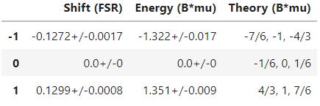

579:

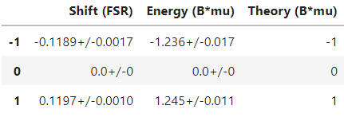

The results from our data analysis are close to the predicted values, but are slightly off in each case by about 0.2 B*mu. The consistency in this error between all 3 of our data sets suggests that this is an error due to the sensitivity of the apparatus. The spacing between the lines is also consistent which agrees with this conclusion. Additionally, the predicted values were calculated using g-factors based on quantum numbers, while the experimental g-factors are different meaning that the measured values would be different from our predicted values found using quantum numbers.

There is also the interesting case of the 577 lines. There are 9 predicted lines, but our data only shows 3. This is because our experimental apparatus does not have the sensitivity to distinguish all of the Zeeman split levels. A larger magnetic field would need to be applied which would cause the yellow lines to overlap which we would be unable to analyze.

In general our results displayed the expected qualitative behavior, but the sensitivity of the set up and the lack of resolution mean that some of the quantitative effects cannot be observed.

## Assessment and Discussion (AL, CN, JD 5/31/2022-)

Compared to the values expected in the literature, ours were within error for the green and yellow lines. (These are shown and discussed above in the Final Analysis section as well.) Thus, our results were consistent with the literature. This may be because of the amount of data we took, our calibration steps, and the fact that we used completely digital analysis for everything except the mirror separation, eliminating a lot of the error associated with humans taking the measurements.

However, our energy values in terms of B*mu were not what was expected for 577 and 579 (other than the 0 values) (shown in tables in the Final Analysis section above). For both the positive and negative energy values for each 577 and 579, were larger in magnitude than theory would predict by approximately 20-30%. Additionally, for the 577 transition, it is predicted that there should be 9 lines present under a magnetic field. Only 3 were seen in our experiment because our experimental apparatus did not have the resolution necessary to observe the splitting between the different Δmj transitions. As shown in the table for the 577 transition in the previous section, the theoretical energies for each Δmj transition are close to each other.

There are several factors that could explain this. For example, the values for the g-factor we used were estimations that were made using quantum numbers which do not hold experimentally, and thus may have affected our calculations. Additionally, the experiment was extremely sensitive; therefore, if our magnetic field values were slightly off of what the equipment stated, this could have produced a large difference in our calculated energies.. Lastly, we had to manually measure our free spectral range (FSR) by eye using a microscope, which could have led to errors that would have affected our results.

We made a mistake on the first day of data collection on the PDA-700 current amplifier, but we resolved this by coming back in and retaking that data with all our settings carefully analyzed. Once we got our reported final data, all the settings were proper and as described above in our experiment notes.